IN THE HIGH COURT OF ALLAHABAD
Civil Misc. Writ Petition Nos. 33828, 32707, 33825, 33827, 33828, 33829, 33830, 33831, 33832, 33834, 33847, 33848, 34042, 34217, 34222, 34551, 34731, 34885, 35385, 35408, 35500, 35501, 35502, 35503, 35504 of 2012
Decided On: 25.07.2012
Appellants: Hari Shanker and Others
Vs.
Respondent: State of U.P. and Others
Hon'ble Judges/Coram:
V.K. Shukla, J.
JUDGMENT
Hon'ble V.K. Shukla, J.
1. In this bunch of writ petitions, the petitioners have rushed to this Court complaining therein that each one of the petitioners had been appointed as untrained assistant teacher on compassionate basis in basic schools run and managed by the U.P. Basic Shiksha Parishad. Each one of the petitioners had been appointed as assistant teacher on compassionate basis under the orders passed by the respective District Basic Educations Officers, with clear cut stipulation that the said engagement was being made for a fixed pay of Rs. 7300/- per month, and after the appointment in question was made in consonance with the terms and conditions of the Government Order dated 4th September, 2000, each one of the petitioners was required to acquire B.T.C. training qualification, and regular appointment was be treated only after the incumbent successfully completed the B.T.C. Course. Appointment as untrained teacher had been offered, and had been accepted. Some of the petitioners have been sent for B.T.C. training course also. The services of each one of the petitioners have been disengaged pursuant to circular letter dated 12.6.2012 issued by the Secretary, Basic Education Board, U.P. Allahabad on the premises that untrained teacher cannot be appointed, after enforcement of the U.P. Right of Children to Free and Compulsory Education Rules, 2011. Since pure common question of law is involved in all these writ petitions, they are being decided by a common judgment and writ petition No. 33828 of 2012 is being treated as leading petition. In this writ petition also, the petitioners have been accorded appointment as untrained assistant teacher with indication that they would acquire B.T.C. certificate in consonance with the Government Order dated 4.9.2000 and they would be offered regular appointment only after completing successfully B.T.C. course. However, if they fail in the aforementioned examination, then except for offering appointment on class IV post, there would be no other option. Petitioners of the aforesaid writ petition were sent for training at the District Institute of Education and Training, Budaun. Petitioners have come up with specific case that Secretary, Basic Education Board; U.P. Allahabad has issued circular on 12.6.2012 directing cancellation of compassionate appointment by mentioning that with effect from 27th July, 2011, the Rules known as the U.P. Right of Children to Free and Compulsory Education Rules, 2011 has come into force, and as per the same, without passing Teacher Eligibility Test (T.E.T.) no one can be offered appointment and accordingly, all those incumbents, who have been offered appointment in breach of the aforesaid Rules, their appointments have been directed to be cancelled. Pursuant to the aforementioned circular issued by the Secretary, Basic Education Board, respective District Basic Education Officers have proceeded to pass orders canceling the appointment of the petitioners. At this juncture, petitioners have approached this Court.
2. On the matter being taken up, Sri Niraj Updhyaya, learned standing counsel as well as Sri A.K. Yadav, Advocate representing the Basic Education Board, contended that since in this bunch of writ petitions pure legal question is involved, pure legal submissions would be advanced and the requisite pleadings are there in writ petition, as such they do not propose to file any counter-affidavit. Similar stand has been taken by other respective counsel appearing for the respondents.
3. Sri Ashok Khare and Sri M.D. Singh Shekhar, Senior Advocates, submitted with vehemence that grant of compassionate appointment to the petitioners was an exception to normal rule of appointment and in the present case, each one of the petitioners had been validly appointed as untrained assistant teacher in consonance with the Government Order, which held the field providing for compassionate appointment. In view of this, the appointment so made in no way was to be affected on the strength of Board's circular dated 12.6.2012, and further as field of offering compassionate appointment remains intact, the same is beyond the scope of the Right of Children to Free and Compulsory Education Act, 2009 (called "the Act, 2009", for short), as such passing of order of cancellation of petitioners' appointment, that too without providing opportunity of hearing, is unjustifiable and uncalled for. Argument to the similar effect has been advanced by other counsel representing the petitioners.
4. Countering the said submissions, Sri Niraj Updhyaya, learned standing counsel as well as Sri A.K. Yadav, Advocate representing the Basic Education Board, on the other hand, contended that once 2009 Act, which is Central Act, has been enforced, then in view of Section 23 (2) thereof, which opens with non-obstante clause, any incumbent without having passed the T.E.T. cannot be appointed as assistant teacher, and as far as relaxation in eligibility criteria is concerned, same is the prerogative of the Central Government, and till date no such relaxation has been granted. The scheme of the things provided for would go to show that only those selections have been left out, qua which selection process had already started and such appointment may be made in accordance with N.C.T.E. (Determination of Minimum Qualifications For Recruitment of Teachers in School) Regulations, 2001 as amended from time to time as per circular dated 29.7.2011 and sub-para (b) of para 5 provides that qualification prescribed shall apply to all teachers except for the teacher of Physical Education and further regarding Art Education, Craft Education, Home Science, Work Education etc., the same eligibility norms shall continue till such time N.C.T.E. Lays down minimum qualification, and in reference to any fresh appointment, the incumbent has to have T.E.T. to his/her credit, and as far as petitioners are concerned, as their engagement as untrained assistant teacher had been done in breach of the aforesaid Act/Rules, as such all the writ petitions deserve to be dismissed.
5. In order to appreciate the respective arguments so advanced relevant statutes are being looked into. There are three statutes relevant in this matter. One is "Uttar Pradesh Basic Education Act, 1972" (hereinafter referred to as "Act 1972") and the Rules framed thereunder, Second is "National Council For Teacher Education Act, 1993" (hereinafter referred to "Act 1993") and third is "Right of Children to Free and Compulsory Education Act, 2009" (hereinafter referred to as "Act 2009").
6. Prior to the enactment of Act 1972, primary education in the State was in quite disorganized manner. There were two types of Primary Schools running in the entire State. One owned and managed by local bodies and rests were private institutions. In the rural areas, primary schools of first category were being managed by Zila Parishads and in urban areas they were being run by Municipal Boards and Mahapalikas etc. The funds to these schools were the responsibility of concerned local bodies. Privately managed Primary Schools were also having two types of categories, one which were solely managed by private bodies from their own resources and rest were those which were getting some kind of financial grant/assistance from State Government through Education Department or some other Departments like Harijan and Social Welfare etc.
7. To bring uniformity in Primary schools run by Local Bodies, considering day to day deteriorating conditions of such schools, a public demand through their representatives was raised requiring State to take immediate steps for improving primary education in the State and hence with an objective of reorganization, reformation and expanding elementary education, State Government came forward to take over control of such schools, as were being run by Local Bodies into its own hands. It enacted U.P. Basic Education Ordinance 1972 giving effect to its provisions w.e.f. Educational Session 1972-73. The said ordinance was substituted by Act 1972. It provided for establishment of U.P. Board of Basic Education (in short the 'Board') and by virtue of Section 9, all the employees of Primary Schools maintained by local bodies stood transferred and became employee of the Board. Section 19confers power upon the State Government to frame rules for the purpose of carrying out Act 1972 in general and in particular the recruitment and conditions of service of the persons appointed to the post of officers, teachers and employees under Section 6 and 9 and also in respect to such staff teaching and non teaching of other basic schools recognized by the Board. The provisions of Act 1972 was given overriding effect over otherwise provisions in U.P. Panchayat Raj Act, 1947, U.P. Municipalities Act, 1916 and U.P. Municipal Corporation Act, 1952 by inserting Section 13A w.e.f. 21st June, 1979. All the basic schools in the State of U.P., now, if recognized by the Board, have to conform to the provisions of Act 1972 and the rules framed thereunder.
8. In respect to teachers of Primary Schools maintained by the Board, Rules 1981 have been framed known as U.P. Basic Education (Teachers) Service Rules, 1981, published in U.P. Gazette (Extra Ordinary) on 3.1.1981. The application of these rules is provided in Rule 3, as under:
Extent of application.--These rules shall apply to:
(i) All teachers of local bodies transferred to the Board under Section 9 of the Act; and
(ii) all teachers employed for the Basic and Nursery Schools established by the Board.
9. Rule 4 deals with the strength of the service. Rule 5 deals with the source of recruitment. Rule 6 deals with the age. Rule 8 deals with the academic qualifications and mentions that essential qualification of the candidates for appointment to a post referred to in Clause (5) of rule 5 would be as shown below against each. Rule 8 is being extracted below:
8. Academic Qualifications.--The essential qualifications of candidates for appointment to a post referred to in clause (a) of Rule 5 shall be as shown below against each:
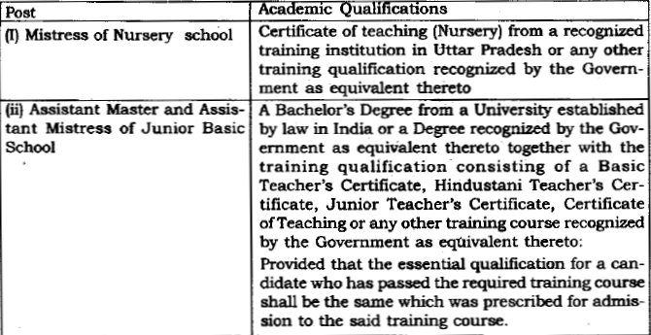
(2) The essential qualifications of candidates for appointment to a post referred to in sub-clause (iii) and (iv) of clause (h) of Rule 5 for teaching Science, Mathematics, Craft or any language other than Hindi and Urdu shall be as follows:
(I) A Bachelor's Degree from a University established by law in India or a Degree recognized by the Government as equivalent thereto with Science, Mathematics, Craft or particular language, as the case may be, as one of the subjects, and
(II) Training qualification consisting of a Basic Teacher's Certificate, Hindustani Teacher's Certificate, Junior Teacher's Certificate, Certificate of Teaching or any other training course recognized by the Government as equivalent thereto.
(3) The minimum experience of candidates for appointment to a post referred to in clause (b) of Rule 5 shall be as shown below against each:
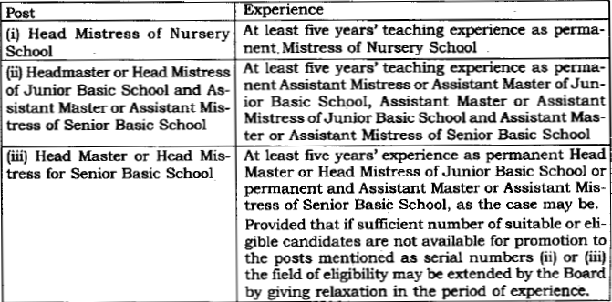
(4) The essential qualifications of candidates for appointment to the post referred to in clause (a) and sub-clause (iii) and (iv) of clause (b) of Rule 5 for teaching Urdu Language shall be as follows:
(i) A Bachelor's Degree from a University established by law in India or a Degree recognized by the Government as equivalent thereto with Urdu as one of the subjects.
Note: A candidate who does not possess the aforesaid qualification in Urdu shall be eligible for appointment if he possesses a Master's Degree in Urdu.
(ii) Basic Teacher's Certificate from any of the training centers in Lucknow, Agra, Mawana in district Meerut and Sakaldiha in district Chandauli established by the Government for imparting training for teaching Urdu or any other training qualification recognized by the Government as equivalent thereto.
10. Rule 10 of the aforesaid Rules deals with the authority of relaxation for ex-servicemen and certain other categories, which is inclusive of compassionate appointment also, and the same reads as below:
10. Relaxation for ex-servicemen and certain categories.--Relaxation, if any, from the maximum age limit, educational qualifications or/and any procedural requirements of recruitment in favour of the ex-servicemen, disabled military personnel, dependents of military personnel dying in action, dependents of Board's servants dying in harness and sportsmen, in accordance with the general rules and orders of the Government in this behalf in force at the time of recruitment.
11. Rule 14 deals with determination of vacancies and preparation of list. Rule 15 deals with notification of vacancies and preparation of list of eligible candidates for certain posts/ Rule 16 deals with constitution of selection committee. Rule 17 deals with procedure for direct recruitment to a post for teaching a language. Rule 17A deals with procedure for direct recruitment to a post for teaching subjects other than language. Rule 18 deals with deals with procedure for recruitment by promotion. Rule 19 deals with appointment.
12. In respect of planned and coordinated development for teachers education, the provisions of 1993 Act has been enforced. This is a Central Act enacted by Parliament and after receiving assent of the President on 29.12.1993 was published in the Gazette of India, (Extra.) Part II, Section 1, dated 30.12.1993. Section 1(3)provides that Act 1993 shall come into force on such date as the Central Government may appoint by notification in initial gazette. Pursuant thereto the Central Government by notification dated 1.7.1995 appointed the same day i.e. 1.7.1995 for enforcement of Act 1993.
13. The Act 1993 was enacted with an objective of achieving planned and coordinated development for teacher education system throughout the country, the regulation and properly maintenance of norms and standards in teacher education system and for matters connected therewith. The Act 1993 contemplates establishment of a council called as "National Council For Teacher Education" (hereinafter referred as "NCTE") and its functions art enumerated in detail in Section 12 of Act 1993. It clearly talks of planned and coordinated development of teacher education, and determination and maintenance of standards for teacher education. It is in this regard various subjects and functions of NCTE have been enumerated in Section 12 from Clauses (a) to (n).
14. The Act 1993 contemplates recognition and permission of NCTE for running courses or training in teacher education. Section 17 provides, if course or training in teacher education has been imparted or obtained in violation of the provisions of the Act, such course or training shall not be treated a valid qualification for the purpose of employment under Central Act, State Government, University, any School/College or other educational body aided by Central or the State Government. The restriction imposed by Section 17(4) is only to the extent that a training or course in teacher education which does not conform to the various provisions of Act 1993 shall not be a valid qualification for employment as stated above, and nothing more and nothing less. The entire Act 1993 does not talk of the manner in which appointments of teachers shall be made, the eligibility to be laid down for appointment of teachers in Primary Schools etc. except qualification. It is confined to the standard and quality of teachers' education. NCTE can lay down minimum qualification which may be prescribed for appointment of a teacher but it does not control the mode, manner and other relevant provisions regarding recruitment and appointment of such teachers. In State of U.P. and Others v. Bhupendra Nath Tripathi and others, : 2010 (5) ESC 630, the Apex Court has clarified this situation that NCTE can lay down minimum qualification for appointment. of teacher by competent appointing authority or the authority competent to frame rules and regulations may lay down any qualification over and above the minimum qualification prescribed by N.C.T.E.
15. Article 41 in Part IV (Directive Principles of State Policy) provides that the State shall, within the limits of its economic capacity and development, make effective provision for securing right to work, to education etc. Similarly Article 45 provides that State shall endeavour to provide, within a period of ten years from the commencement of Constitution, free and compulsory education for all children until they complete the age of fourteen years. Said provisions have come up before Apex Court in Mohini Jain v. State of Karnataka, : AIR 1992 SC 1858 and Unni Krishnan J.P. v. State of A.P. : AIR 1993 SC 2178 and the cases followed thereafter observing Primary Education to children from age of 6 to 14 years as a constitutional right, efforts were made by Governments, Central and State both, to expand primary education by establishing primary schools at Village Panchayat level in a major way and this really gave opportunity to open number of new schools and correspondingly increase in number of teachers requiring to man these institution. Parliament also recognized above right by inserting Article 21A in the Constitution i.e. 'Right to Education', by Constitution (86th Amendment) Act, 2002, and, simultaneously inserted Clause (k) in Article 51A vide Section 4 of Constitution (86th Amendment) Act, 2002. The Parliament also in furtherance of the above constitutional provisions, come forward by enacting Act 2009 published in Gazette of India on 27.8.2009. By virtue of Section1(3) of Act 2009, it has been given effect from 1.4.2010.
16. One of the major change it has brought, besides other, is that no Primary School other than a school established, Owned or controlled by the appropriate Government or local body after commencement of 2009 Act shall be established or function without obtaining a certificate of recognition from such authority, as may be prescribed. For the purpose of seeking recognition, the school has to conform the norms and standard specified in Section 19 of Act 2009 read with the schedule appended thereto. The Act 2009, vide Section 23(1), also provides that any person possessing such minimum qualification, as laid down by an academic authority authorized by the Central Government, by notification, shall be eligible for appointment as a teacher.
17. Section 23 (2) of the Right of Children to Free and Compulsory Education Act, 2009 further proceeds to mention that where a State does not have adequate institutions offering courses for training in teacher education or teachers possessing minimum qualifications as laid down under sub-section (1) are not available in sufficient numbers, the Central Government may, if it deems necessary, by notification relax the minimum qualifications required for appointment as a teacher, for such period, not exceeding five years, as may be specified in that notification. A proviso has also been added to the aforesaid sub-section (2) of Section 23 mentioning that a teacher who at the commencement of this Act, does not possess minimum qualification as laid down under subsection (1), shall acquire such minimum qualification within a period of five years. For the sake of convenience the provisions of sub-sections (1) and (2) of Section 23 are being excerpted below:
23. Qualifications for appointment and terms and conditions of service of teachers.--(1) Any person possessing such minimum qualifications, as laid down by an academic authority authorized by the Central Government by notification shall be eligible for appointment as a teacher.
(2) Where a State does not have adequate institutions offering courses for training in teacher education or teachers possessing minimum qualifications as laid down under sub-section (1) are not available in sufficient numbers, the Central Government may, if it deems necessary, by notification relax the minimum qualifications required for appointment as a teacher, for such period, not exceeding five years, as may be specified in that notification.
Provided that a teacher who at the commencement of this Act, does not possess minimum qualification as laid down under sub-section (1), shall acquire such minimum qualification within a period of five years.
18. In exercise of powers conferred by Section 38 of 2009 Act, Rules have been framed and the same have been published in the gazette dated 9.4.2010. Part VI of the said Rules deals with the term "teacher". Rule 17 deals with minimum qualification, Rule 18 deals with relaxation of minimum qualification, Rule 19 deals with acquiring minimum qualifications. Rules 17, 18 and 19 of the aforesaid Rules are being quoted below:
17. Minimum Qualifications.--(1) The Central Government shall, within one month of the appointed date, notify an academic authority for laying down the minimum qualifications for a person to be eligible for appointment as a teacher.
(2). The academic authority notified under sub-rule (1) shall within three months of such notification, lay down the minimum qualifications for a person to be eligible for appointment as a teacher in an elementary school.
(3). The minimum qualifications laid down by the academic authority referred in sub-rule (1) shall be applicable for every school referred to in clause (n) of Section 2.
18. Relaxation of minimum qualifications.--(1) The State Government and Union Territory shall, within six months from commencement of the Act, estimate the teacher requirements as per the norms in the Schedule of all schools referred to in clause (n) of Section 2
(2) Where as State Government or Union Territory does not have adequate institutions offering courses or training in teacher education, or persons possessing minimum qualifications as notified in sub-rule (2) of rule 17 are not available in sufficient numbers in relation to the requirement of teachers estimated under sub-rule (1) the State Government or the Union Territory shall request, within one year of the commencement of the Act, the Central Government for relaxation of the prescribed minimum qualifications.
(3) On receipt of the request referred to in sub rule (2), the Central Government shall examine the request of the State Government or the Union Territory and may, by notification relax the prescribed minimum qualifications.
(4) The notification referred to in sub rule (3) shall specify the nature of relaxation and the time period, not exceeding thee years, but not beyond five years from the commencement of the Act, within which the teachers appointed under the relaxed conditions acquire the minimum qualifications specified by the academic authority notified under sub-section (1) of Section 23.
(5) After six months from the commencement of the Act, no appointment of teacher for any school can be made in respect of any person not possessing the minimum qualifications notified in sub-rule (2) of Rule 17, without the notification of relaxation referred to in sub-rule(3).
(6) a person appointed as a teacher within six months of the commencement of the Act, must possess as least the academic qualifications nor lower than higher secondary school certificate or equivalent.
19. Acquiring minimum qualifications.--(1) The State Government and Union Territory shall provide adequate teacher education facilities to ensure that all teachers in schools referred to in sub-clause (I), and schools owned and managed by the Central Government or the State Government or Union Territory or local authority under sub-clause (iii) of clause (n) of Section 2, who do not possess the minimum qualifications laid down under sub-rule (2) of Rule 17 at the time of commencement of the Act, to acquire such minimum qualifications within a period of five years from the commencement of the Act.
(2) For a teacher, or a school referred to in sub-clause (ii) and (iv) of clause (n) of Section 2 and of a school referred to in sub clause (iii) of clause (n) of Section 2 not owned and managed by the Central Government, State Government or Union Territory or local authority, who doe not possess the minimum qualifications laid down under sub-rule (2) of rule 17 at the time of commencement of the Act, the management of such school shall enable such teacher to acquire such minimum qualifications within a period of five years from the date of commencement of the Act.
19. In exercise of powers conferred by sub-section (1) of Section 23 of 2009 Act, the Central Government has authorized the National Council for Teachers Education (NCTE) as Academic Authority to lay down minimum qualifications for a person to be eligible for appointment as teacher. In exercise of the said authority, the N.C.T.E. has proceeded to lay down minimum qualifications for a person to be eligible for appointment as teacher. Said Notification has been published on 23.8.2000, and thereafter fresh notification has been issued with modifications on 29.7.2011. Relevant extract of the same is extracted below:
NATIONAL COUNCIL FOR
TEACHER EDUCATION
NOTIFICATION
New Delhi, the 29th July, 2011
F. No. 61-1/20U/NCTE/N & S).-In exercise of the powers conferred by sub-section (1) of the Section 23 of Right of Children to Free and Compulsory Education Act, 2009 (35 of 2009) and in pursuance of the Notification No. S.O. 750(E) dated 31st March, 2010 issued by the Department of School Education and Literacy, Ministry of Human Resource Development, Government of India, the National Council for Teacher Education (NCTE) hereby makes the following amendments to the Notification No. 215 dated 25th August, 2010 published in the Gazette of India, Extraordinary, Part-III, Section-4, vide F. No. 61-1/2011-NCTE (N & S), dated the 23rd August, 2010, laying down the minimum qualifications for a person to be eligible for appointment as a teacher (hereby referred to as the Principal Notification), namely :
(I) For sub-para (i) of para 1 of the Principal Notification, the following shall be substituted, namely :
1. Minimum Qualifications :
(i) Classes I-V
(a) Senior Secondary (or its equivalent) with at least 50% marks and 2-year Diploma in Elementary Education (by whatever name known) OR Senior Secondary (or its equivalent) with at least 45% marks and 2-year Diploma in Elementary Education (by whatever name known), in accordance with the NCTE (Recognition Norms and Procedure), Regulations, 2002.
OR
Senior Secondary (or its equivalent) with at least 50% marks and 4-year Bachelor of Elementary Education (B.E1.Ed.)
OR
Senior Secondary (or its equivalent) with at least 50% marks and 2-year Diploma in Education (Special Education) OR Graduation and two year Diploma in Elementary Education (by whatever name known)
AND
(b) pass in the Teacher Eligibility Test (TET), to be conducted by the appropriate Government in accordance with the Guidelines 16 framed by the NCTE for the purpose.
(II) For sub-para (ii) of para 1 of the Principal Notification, the following shall be substituted, namely :
1. (ii) Classes VI - VIII
(a) Graduation and 2-year Diploma in Elementary Education (by whatever name known)
OR
Graduation with at 50% marks and 1-year Bachelor ion Education (B.Ed.)
OR
Graduation with at least 45% marks and 1-year Bachelor in Education (B.Ed.), in accordance with the NCTE (Recognition Norms and Procedure) Regulations issued from time to time in this regard.
OR
Senior Secondary (or its equivalent) with at least 50% marks and 4-year Bachelor in Elementary Education (B.E1.Ed.)
OR
Senior Secondary (or its equivalent) with at least 50% marks and 4-year B.A./B.Sc.Ed. or B.A. Ed./B.Sc.Ed
OR
Graduation with at least 50% marks and 1-year B.Ed. (Special Education)
AND
(b) Pass in Teacher Eligibility Test (TET), to be conducted by the 17 appropriate Government in accordance with the Guidelines framed by the NCTE for the purpose.
(III) For para 3 of the Principal Notification the following shall be substituted, namely :
(i) Training to be undergone :A person (a) with Graduation with at least 50% marks and B.Ed. qualification or with at least 45% marks and 1-year Bachelor in Education (B.Ed.), in accordance with the NCTE (Recognition Norms and Procedure) Regulations issued from time to time in this regard shall also be eligible for appointment to Class I to V up to 1st January, 2012, provided he/she undergoes, after appointment, an NCTE recognized 6-month Special Programmer in Elementary Education;
(b) with D.Ed. (Special Education) or B.Ed. (Special Education) qualification shall undergo, after appointment an NCTE recognized 6-month Special Programme in Elementary Education.
(ii) Reservation Policy :
Relaxation up to 5% in the qualifying marks shall be allowed to the candidates belonging to reserved categories, such as ST/ST/OBC/PH.
(IV) For para 5 of the Principal Notification, the following shall be substituted, namely :
5. (a) Teacher appointed after the date of this notification in certain cases : Where an appropriate Government or local authority or a school has issued an advertisement to initiate the process of appointment of teachers prior to the date of this Notification, such appointments may be made in accordance with the NCTE (Determination of Minimum Qualifications for Recruitment of Teachers in Schools) Regulations, 2001 (as amended from time to time).
(b) The minimum qualification norms referred to in this Notification apply to teachers of Languages, Social Studies, Mathematics, Science, etc. In respect of teachers for Physical Education, the minimum qualification norms for Physical Education teachers referred to in NCTE Regulation dated 3rd November, 2001 (as amended from time to time) shall be applicable. For teachers of Art Education, Craft Education, Home Science, Work Education, etc. the existing eligibility norms prescribed by the State Governments and other school managements shall be applicable till such time the NCTE lays down the minimum qualifications in respect of such teachers.
20. A perusal of the aforesaid notification would go to show that minimum qualification has been provided for a person to be eligible for appointment as teacher and in addition to it, it has also been provided that the incumbent has to pass Teacher Eligibility Test (T.E.T.) to be conducted by the appropriate Government in accordance with the guidelines framed by the N.C.T.E. for the purpose and paragraphs 5 (a) and 5 (b) of said circular has carved out exception to the applicability of said Circular. In the State of U. P. Rules have been framed known as U.P. Right of Children to Free and Compulsory Education Rules, 2011, and therein part VI thereof deals with 'teacher'. Rule 15 deals with minimum qualification of teachers, rule 16 deals with relaxation of minimum qualification, Rule 17 deals with acquiring of minimum qualifications. Said Rules have been enforced with effect from 27th July, 2011. The aforesaid Rules 15, 16 and 17 of the aforesaid Rules are being quoted below:
15. Minimum qualification of teachers (Section 23 (1).--The minimum educational qualifications for teachers laid down by an authority authorized by the Central Government, by notification, shall be applicable for every school referred to in clause (n) of Section 2.
16. Relaxation of minimum qualification (Section 23 (2).--(1) The State Government shall estimate the teacher requirement as per the norms in the Schedule for all schools referred to in clause (n) of Section 2 within the State.
(2) If teachers possessing prescribed minimum qualifications are not available as estimated under sub-rule (1), then the State Government shall request the Central Government by 31st March, for relaxation of the prescribed minimum qualification.
(3) The State Government shall take necessary action after the notification issued by the Central Government, for relaxation in the minimum qualification on the request under sub-rule (2).
(4) The relaxation from minimum qualifications shall be for maximum period of five years from the commencement of the Act, i.e. till 31st March, 2015, within such period the teachers appointed under relaxed condition shall acquire the minimum educational qualifications prescribed under rule 15.
(5) No appointment of teacher for any school can be made in respect of any person not possessing the minimum qualifications prescribed under Rule 15 without the notification referred to in sub-rule (3).
17. Acquiring of minimum qualification (proviso to Section 23 (2).--The State Government shall made a request to the academic authority notified by the Central Government for enhancement of capacity of teacher education and for providing required facilities for distant mode teacher training to ensure that all teachers in schools established, owned or controlled by the State Government or a local authority or specified schools, who do not possess the minimum qualifications laid down under Rule 15 at the time of commencement of the Act, acquire such minimum qualifications within a period of five years from the commencement of the Act. The State Government shall after obtaining the approval as per requirement provide for training of all such teachers.
(2) The management of aided or unaided schools shall enable such teachers, who do possess the minimum qualifications laid down under Rule 15 at the time of commencement of the Act, to acquire the same within a period of five years from the commencement of the Act.
21. Thereafter, in the State of U.P. amendment has been introduced in the U.P. Basic Education (Teachers) Service Rules, 1981 on 9.11.2011, and Rule 8 thereof has been amended known as U.P. Basic Education (Teachers) Service (Twelfth Amendment) Rules, 2011. A chart containing existing rule as well as amended rule is being extracted below:
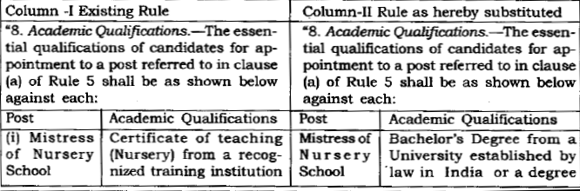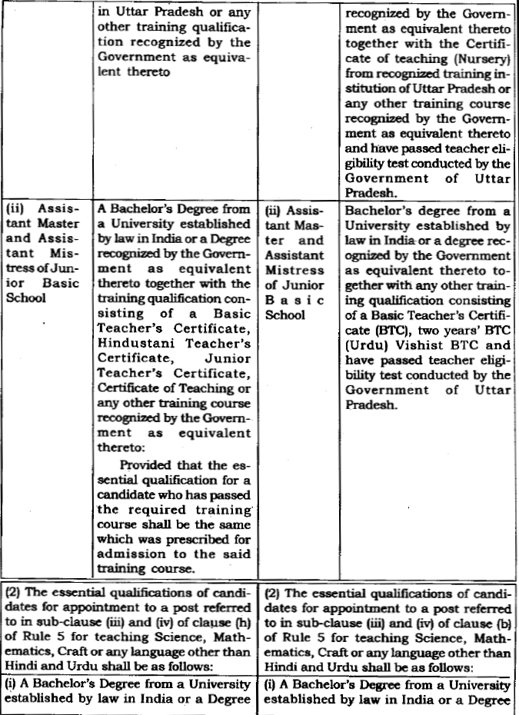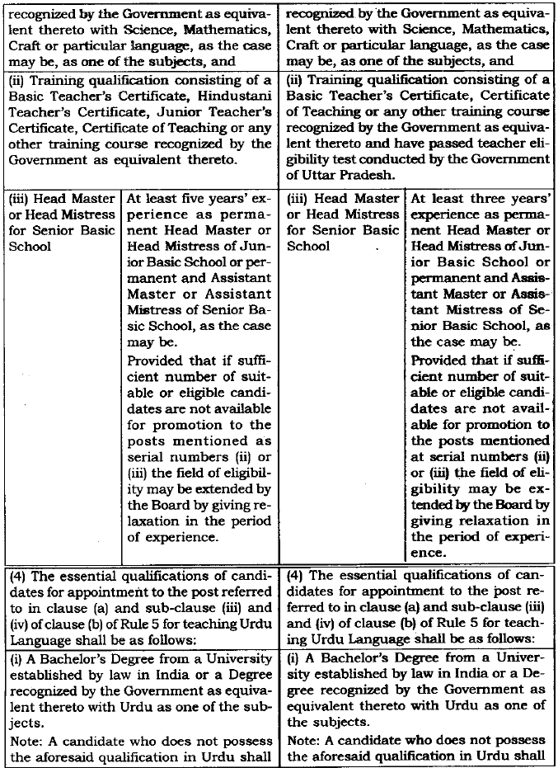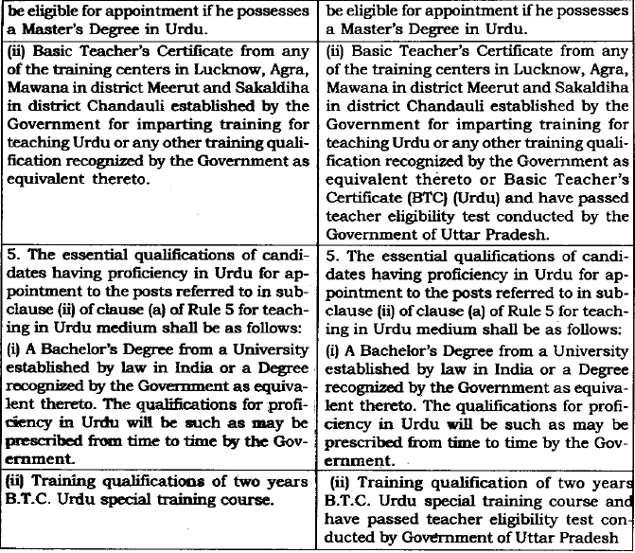
22. In respect of grant of compassionate appointment under 1981 Rules, there is no specific provision. Rule 10 of the 1981 Rules talks of relaxation and the State Government in its turn has issued Government Order on 4.9.2000 dealing with the grant of compassionate appointment. Relevant extract of the said Government Order is being quoted below:
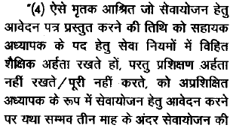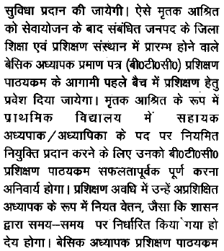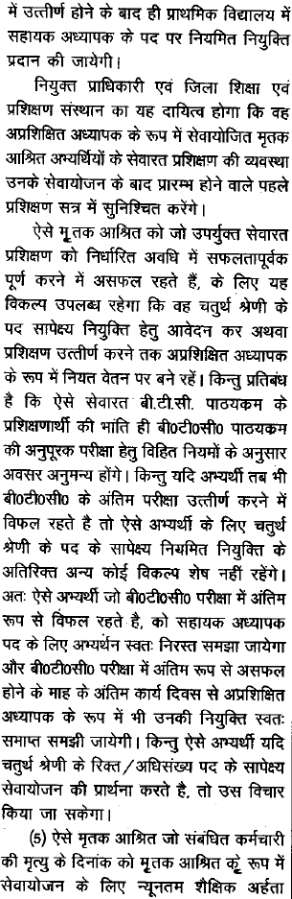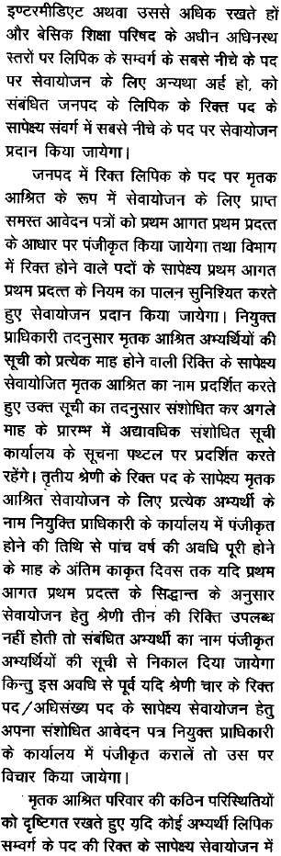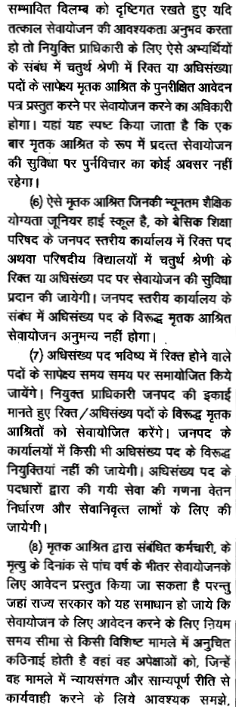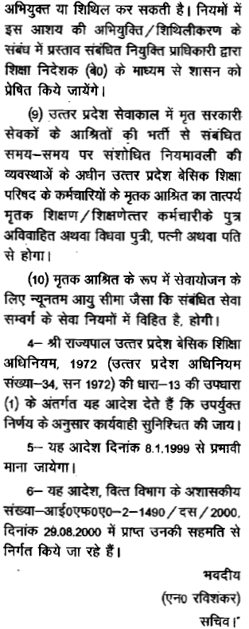
23. On the parameters of the provisions quoted and discussed above, the case in hand is being looked into. Each one of the petitioners, claims to have been appointed in consonance with the Government Order dated 4.9.2000. In the said Government Order a specific provision has been provided therein that all those incumbents who fulfill the requisite educational qualification, but do not have training qualification, they can move application for grant of compassionate appointment and the said incumbent would be offered appointment and shall be sent for training of B.T.C. course in the respective District Institutes of Education and Training, and after they successfully complete the training, they would be offered appointment on regular basis. However, in case an incumbent fails to pass the aforesaid examination, his candidature would automatically stand cancelled and he would be offered appointment on class IV post and his claim may also be considered for appointment against class III post as per the exigency.
24. The moot question before this Court is that when the provisions of the Right of Children to Free and Compulsory Education Act, 2009 have been enforced and necessary eligibility criteria has been fixed for being appointed as a teacher in the institutions defined under Section 2 (n) of the said Act, then as to whether appointment of an untrained person as teacher is feasible or not? by invoking the provisions of relaxation in the matter of compassionate appointment.
25. The Right of Children to Free and Compulsory Education Act, 2009 has been enforced with effect from 27th August 2009 in the belief that the value of equality, social justice, democracy and creation of just a humane society can be achieved only through the elementary education to all. The provisions of the Right of Children to Free and Compulsory Education Act, 2009 also aims at including the children from disadvantaged group and weaker sections to get education, in consonance with the provisions of Article 21A of the Constitution. Apart from dealing with the right of children to free and compulsory education and making of special provision in the said direction, the Parliament has taken care of the fact that the teachers who are there to impart education, they should have also certain qualification for being appointed, and in view of this clear cut mandate has been made under Sub-section (1) of Section 23 of the said Act, that person possessing such minimum qualification as laid down by the academic authority authorized by the Central Government by notification, shall be eligible for being appointed as teacher. Subsection (2) of Section 23 of 2009 Act gives liberty to the State Government to collect data of the adequacy of the institutions offering courses of training education, and in case teachers possessing minimum qualifications are not available in sufficient number, requesting Central Government to relax the minimum qualification required for appointment as a teacher, for such period not exceeding five years, as may be specified in the notification. A proviso has also been added providing that a teacher who at the commencement of this Act, does not possess minimum qualification as laid down under sub-section (1), shall acquire such minimum qualification within a period of five years. Apex Court in the case of State of U.P. v. Bhupendra Nath Tripathi,2010(5) ESC 630 (SC), apart from holding that State can fix higher qualification, has taken the view that proper training of teacher is integral aspect in effectuation of right of education. Right conferred under Article 21A of the Constitution would remain illusory in the absence of State taking adequate steps to have required number of schools manned by efficient and qualified teachers. Precise mention has been made that before teachers are allowed to teach the children, they are required to receive appropriate and adequate training from duly recognized training institute.
26. The authority to fix minimum qualification has been out sourced by the Central Government and the NCTE has been declared as authorized academic authority to lay down minimum qualification for a person to be eligible for being appointed as teacher. The N.C.T.E. in its turn has proceeded to notify the educational qualification on 5.4.2010 as is required by Section 23 (2) of the 2009 Act and different sets of minimum qualifications have been provided for teachers for class I to V and class VI to class VIII with requirement to pass T.E.T. to be conducted by the appropriate Government in accordance with the guidelines framed for the purpose. The T.E.T. as such has to be conducted by the State Government. For the purpose of implementation of 2009 Act Rules have also been framed known as U.P. Right of Children to Free and Compulsory Education Rules, 2011 and the said Rules have been enforced with effect from 27th July, 2011. Said Rules have been framed in supercession of all existing rules and orders on the subject, and Rule 15 is clear that minimum educational qualification for teachers laid down by an authority authorized by the Central Government shall be applicable for all schools referred to in clause (n) of Section 2. The State Government in its turn on 7.9.2011 proceeded to authorize the Madhyamik Shiksha Parishad to hold the T.E.T., and accordingly guidelines had also been issued to be complied with for passing T.E.T. (Teacher Eligibility Test)
27. Under the U.P. Basic Education Act 1972 and the Rules 1981. The qualification required to be possessed by a teacher for appointment in a Primary School is provided in Rule 8 of Rules 1981. This rule has undergone amendments from time to time broadly. Initially it provides for a qualification up to High School and training qualification like Basic Teachers Certificate, Junior Teacher Certificate, Certificate of Teaching etc. Later on amendments were made which basically increase educational qualification of High School to Intermediate and then to Graduation but so far as training qualification is concerned, the same continue to be as such. For the first time, an amendment was made in 2004 by adding "Special Basic Teachers Certificate Course" as one of the training qualification under Rule 8(1). Subsequently another amendment came to be made by notification dated 25.11.2006 in Rule 8(1). In the U.P. Basic Education (Teachers) Services Rules, 1981 also amendment has been sought to be introduced on 9.11.2011 known as U.P. Basic Education (Teachers) Services (Twelfth Amendment) Rules, 2011, and by means of this amendment for a person to be appointed as teacher T.E.T. is a must.
28. Under the U.P. Basic Education (Teachers) Service Rules, 1981, as amended till date, there is no specific provision of compassionate appointment, however, Rule 10 thereof talks of certain relaxations from the maximum age limit, educational qualification or/and any procedural requirements of recruitment in favour of the ex-servicemen, disabled military personnel, dependents of military personnel dying in action, dependents of Board's servants dying in harness and sportsmen, in accordance with the general rules and orders of the Government in this behalf in force at the time of recruitment. Thus, Rule 10 talks of relaxation, but the same has to be in accordance with the general rules and orders of the Government in this behalf in force at the time of recruitment. Petitioners submit that Government Order dated 4.9.2000 is there, and accordingly, rightful action has been taken by offering appointment as untrained teacher.
29. In the present case factual situation which has so emerged, is that under 2009 Act, it has already been provided under Section 23 (1) for that only such persons shall be eligible for appointment as teacher who possess such minimum qualifications as is laid down by the academic authority authorized by the Central Government by notification, and the academic authority to lay down minimum qualification for appointment as teacher was the N.C.T.E. and the N.C.T.E. in its turn has clearly proceeded to mention that before being appointed as teacher apart from possessing minimum educational qualification an incumbent has to pass T.E.T. and the State Government was asked to conduct such test and the State Government in its turn had authorized the Madhyamik Shiksha Parishad to hold such test. The minimum qualification prescribed in notification dated 23.8.2010 are in two parts, one for Junior Primary School namely Classes I to V and another is for Senior Primary School i.e. Class VI to VIII. Besides educational qualifications, for the first time, it also introduced eligibility qualification of teacher i.e. Eligibility Test i.e. passing of Teachers Eligibility Test (in short T.E.T.') conducted by concerned Government in accordance with the guidelines laid down by NCTE. NCTE issued a notification on 29.7.2011 in purported exercise of powers under Section 23 of 2009 Act. The aforesaid notification has amended notification dated 23.8.2010. Sub-para (i) and (ii) of Para 1; para 3 and para 5 have been substituted in entirety. Para 5 of notification dated 29.7.2011 is a kind of saving clause and provides that if an advertisement initiating process of appointment of teachers has already been issued before 29.7.2011, such appointments may be made in accordance with NCTE (Determination of Minimum Qualifications for Recruitment of Teachers in Schools) Regulations, 2001 (as amended from time to time).
30. Sub para (b) of para 5 provides that minimum qualification prescribed by notification dated 29.7.2011 shall apply to all teachers except the teacher for Physical Education, for which NCTE Regulation dated 3.11.2001, as amended from time to time, shall continue to apply. Further regarding teachers of Art Education, Craft Education, Home Science, Work Education, etc. the existing eligibility norms prescribed by the State Government and other school managements shall be applicable till such time the NCTE lays down the minimum qualification in respect of such teachers. The above discussion makes it beyond doubt that the above notifications issued by N.C.T.E. lays down minimum qualification, which would make a person eligible for appointment as a teacher in Primary Schools but the manner in which recruitment for appointment on the post of teacher in Primary School shall be made, and, their terms and conditions of service, for the same, aforesaid notification does not provide anything at all and hence in this regard Rules 1981 shall hold the field and would continue to apply. U.P. Right of Children to Free and Compulsory Education Rules, 2011 is also there with effect from 27.7.2011. It clearly provides educational qualification for teacher to be appointed in the institutions defined in clause (n) of Section 2, and same is in supersession of all other Rules on the subject. Under 2009 Act and the Rules framed thereunder, minimum qualifications after enforcement of the Act can be relaxed by the Central Government on the recommendation of the State Government. The State Government ceases to have any authority in the matter of relaxation of educational qualification. Thus, once 2009 Act has come into force and the academic agency authorized by it had already fixed the minimum educational qualification, and U.P. Right of Children to Free and Compulsory Education Rules, 2011 has been enforced, then the same are the general rules and orders of the Government in force at the time of recruitment, and the said provisions will have overriding effect and the other earlier provisions under provincial legislation would sub serve the same.
31. This Court in the case of Smt. Neera Devi v. State of U.P., Civil Misc. Writ Petition No. 7275 of 2011, decided on 5.12.2011 has clearly taken similar view. Relevant extract of the said judgment is being quoted below:
2. Petitioner has sought a mandamus directing the respondents to appoint him as Assistant Teacher even though he does not acquire the requisite training qualification by referring Rule 10 of the U.P. Basic Education (Teachers) Service Rules, 1981 which have been framed under the U.P. Basic Education Act, 1972.
3. In my view no such relief can be granted after enactment of Right of Children to Free and Compulsory Education Act, 2009 (hereinafter referred to as "Act, 2009"). The Act 2009, vide Section 23 (1), provides that any person possessing such minimum qualification, as laid down by an academic authority authorised by the Central Government, by notification, shall be eligible for appointment as a teacher. It reads as under:
23. Qualifications for appointment and terms and conditions of service of teachers.--(1) Any person possessing such minimum qualifications, as laid down by an academic authority authorized by the Central Government, by notification, shall be eligible for appointment as a teacher.
4. Since the provision does not contemplate appointment of a Teacher who is not qualified as per Regulations of N.C.T.C., the provisions of compassionate appointment earlier made even if permit unqualified persons to be appointed in certain cases, cannot be followed after framing of Regulations by Authorised Authority. In absence of a statutory provision prior to Act, 2009, the provisions for compassionate appointment permitting appointment of untrained persons could have been complied with since the same had no occasion to infringe any other statute having overriding effect but after Act, 2009 and Regulations framed thereunder, the situation has undergone a sea change. It is not disputed that National Council of Teachers Education has been notified as Authorised Academic Authority under Section 23 (1) and the said body has framed Regulations laying down minimum qualification and eligibility conditions for appointment of Teachers in Primary Schools. In the light of said provisions, which have been made under Act, 2009; the same have overriding effect and, therefore, the otherwise provisions under provincial legislation would sub-serve. I am, therefore, clearly of the view that the relief, as sought in the writ petition, cannot be granted in the above circumstances.
5. The writ petition is dismissed.
32. In the present case each one of the petitioners had been offered appointment after the said notification had been published by the N.C.T.E. followed by U.P. Right of Children to Free and Compulsory Education Rules, 2011 enforceable with effect from 27.7.2011. Rule 10 of the U.P. Basic Education (Teachers Service Rules, 1981 cannot be read in isolation rather it has to be read in the context, it has been provided for. It gives right of relaxation to ex-servicemen and certain other categories, which is inclusive of compassionate appointment as well, but the same has to be in accordance with the general rules and orders of the Government in this behalf in force at the time of recruitment. At the relevant time, N.C.T.E. had already declared educational qualification for teacher to be appointed in school defined under clause (n) of Section 2, which was required alongwith T.E.T. and it was mandatory requirement. No person could have been treated to be eligible for being appointed as teacher without passing the aforesaid requisite qualification as was prescribed by the N.C.T.E. The 2009 Act and the Rules framed thereunder were clear and categorical. The appointments, which had been made prior to enforcement of the Act, were saved, as the incumbents appointed were required to fulfill the eligibility criteria within five years from the enforcement of the Act and in other cases, there has to be specific order by the Central Government on the request of the State Government, and in the present case accepted position is that after enforcement of the Act, N.C.T.E. Norms and U.P. Right of Children to Free and Compulsory Education Rules, 2011, petitioners had been appointed and in view of this relaxation as has been provided for, could not have been accorded. The Government Order in regard to compassionate appointment has been pressed in flagrant violation of statutory provisions, and in view of this Secretary of the Board on being apprised of this factual situation has proceeded to remedy the situation by annulling such appointments which were dehors the statutory provisions. Once appointment of the petitioners was totally contrary to law not at all subscribed by law, none of the petitioners were legally eligible and entitled to be appointed as concept of untrained assistant teacher, is violative of Article21A of the Constitution as untrained teacher cannot be recruited, as proper training of teacher is integral aspect in right of education being effectuated. In view of this, the Secretary of the Board has acted well within his right to direct cancellation of such appointments, which were contrary to law in force on the date when they had been recruited. Principle of natural justice has no role to play in such matters, when appointments made are dehors the statutory provisions, on admitted position, and it would be nothing more but exercise in futility, as result would be one and the same, and quashing of the order on this ground would be nothing but perpetuating the illegality, i.e. permitting untrained teachers to continue.
33. Petitioners have tried to submit that amongst untrained Assistant Teachers, two classes have been created, as service of only those untrained Assistant Teachers have been terminated, who have been appointed after 27.7.2011, i.e., after enforcement of U.P. Right of Children to Free and Compulsory Education Rules, 2011, and the services of untrained teachers appointed prior to it have not been terminated. Negative equality cannot be claimed, and said class of teachers are not before this Court, either individually or collectively, as such this Court is not touching this question and deciding and deciding the said question, and this issue is left open to be decided in appropriate proceedings. In view of what has been discussed above, all the writ petitions are dismissed. The claim of the petitioners be considered against existing class III/IV vacancies except qua class HI vacancies which are to be filled up by way of promotion, preferably within next two months

